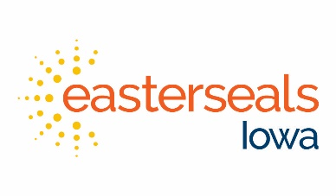

Help Desk & Systems Coordinator

Department: Supporting Functions Classification: FT Non Exempt
Reports to: Director, Data Management & Compensation
Leadership: None Pay Level: CRE1

Principle Accountabilities
- Manage and support all IT needs for the agency
- Manage IT contract and vendor(s)
- Provide technical support for team members
- Ensure team members have appropriate access to Easterseals Iowa systems
- Act as agency HIPAA security officer: ensure fidelity of IT systems for the agency including working closely with contractors and team members to ensure Easterseals Iowa policies are followed
- Identify opportunities for efficiencies by utilizing agency databases effectively including SUNNY, Raiser’s Edge, Financial Edge and iSolved
- Manage SUNNY changes and communicate priorities to leadership.
- Work closely with the Director, Training and Development to provide training for team members on utilizing the agency systems.
- Maintain and ensure accuracy of Sharepoint
- Run background checks for potential new hires when requested
- Run background checks on a rotating schedule for each department on existing team members
- Run monthly OIG checks on current team members
- Manage agency technology inventory and key fob system
- Assist with website changes
- Maintain internal Policy and Procedure Manual
- Compile results from agency Internal survey twice per year
- Coordinate, conduct, and report safety drills for main office location
- Serve as a backup for the Program and Support Specialist
- Other duties as assigned.

Easterseals Values Accountabilities
Integrity: Maintain privacy and security with information in all systems
Customer-Focused: Anticipate team member needs and recognize the variety of skill level team members possess.
Independence: Support team members learn skills that will increase their ability to be high performers.
Shared Purpose: Demonstrate flexibility and a willingness to work with team members to utilize technology effectively find solutions as conflict and crisis arise.
Excellence: Respond with urgency to team member’s questions and needs.

Knowledge, Skills and Experience Requirements
- Extensive knowledge of Office 365
- Extensive knowledge of communication and information technologies
- 1 year of IT internal coordination preferred
- Ability to troubleshoot technology issues on a variety of platforms and devices
- Ability to prioritize and organize multiple projects/tasks
- Ability to work independently and organize workflow
- Ability to communicate effectively in written and verbal formats
- Abiltiy to work with a variety of team members and clients
- Ability to have professional interactions and maintain a professional appearance
- Ability to work under pressure, maintain accuracy and meet deadlines
- Ability to maintain confidentiality
- Ability to identify potential for back office efficiencies utilizing technology
- Access to reliable transportation for regular participation in work
- Ability to pass background check.

I have read and understand the above job description. I understand that this job description is not all inclusive and subject to change.

I further acknowledge that my signature does not constitute a contract between Easterseals and me.

_____________________________________ _____________________
Team member Date

______________________________________ ______________________
Leader Date

Origin: 11/17, Revised; 7/2020, 11/21

